**OBJECTIVES**

By the end of this module, you should be able to:

* Recognize linked decisions and understand the distinct challenges they present
* Explain the DOI definition of adaptive management and how it differs from other characterizations of ‘learning through management’
* Understand the specific roles of monitoring in a decision context
* Understand the concepts of single‐, double‐ and triple‐loop learning

**DYNAMIC OR SEQUENTIAL DECISIONS**

There is a special class of decision problems we haven’t yet addressed. Much of what we’ve talked about thus far has been solving one‐off decisions. However, many of the decisions we face are recurrent – that is, the same type of problem must be solved at regular (or irregular) intervals over time (or over space). These can be referred to as ‘recurrent,’ ‘sequential’ or ‘dynamic’ decision problems.

There are three important properties of dynamic decisions:

1. Returns (management benefits) accumulate over time
2. Future alternatives are affected by previous decisions – i.e., decisions made today affect our choices in the future (and possibly even what alternatives are available to choose from)
3. Future state variables are affected by previous decisions – i.e., decision made today move the system into a new state, which will have to be confronted with future decisions.

The properties of dynamic decisions present an opportunity to learn about the system being managed and, therefore, provide the ability to reduce uncertainty and improve management performance over time.

Key challenge: how to balance short and long-term gains to do well over the entire time frame?

***A familiar example***: Establishing harvest regulations (Johnson et al. 1997)

1. Management agencies are interested in long‐term benefits (hunter satisfaction, high harvest rates). Annual regulation decisions consider cumulative (future) returns rather than attempting to maximize benefits for the current year.
2. The setting of future regulations will be influenced by previous decisions and realized harvest rates (among other variables).
3. Future size of the harvested population will be affected by previous harvest rates. Thus, to ensure sustainable (long‐term) harvest opportunities, current regulations will have to consider the influence on this future state variable (population size).

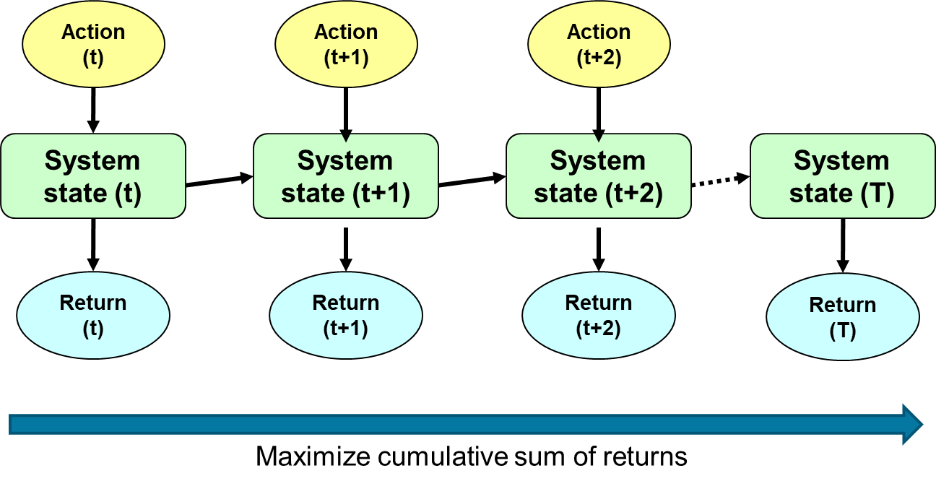

***A generalized depiction of dynamic decision problems***

**DYNAMIC DECISIONS PROVIDE AN OPPORTUNITY FOR LEARNING**

When uncertainty impedes management decisions, dynamic (sequential) decisions can be used to reduce important uncertainties. This requires a systematic approach to learning from management outcomes, with the goal of improving resource management, not learning *per se*.

Two modes of learning can be applied to management under uncertainty:

***Internal learning***

* A process of learning internal to the specific decision context
* Can be customized to produce knowledge specific to the needs of the particular decision problem
* This knowledge can efficiently be applied to future decisions

***External learning***

* A learning process that parallels the decision context
* Related to, but not directly derived from the focal management problem
* Can produce knowledge that is useful to subsequent decisions
* Common sources include
* Related management activities
* New, basic science results
* Expert elicitations

**ADAPTIVE MANAGEMENT**

Adaptive management is a systematic approach for improving resource management in a recurrent decision setting by learning from management outcomes. Adaptive management differs from trial and error in that the critical uncertainty and the response to its resolution are determined *a priori*, whereas in trial and error, alternative hypotheses and interventions are only developed after failure is observed.

The Department of the Interior uses a decision‐analytic definition of adaptive management, one that could be described as ‘SDM for recurrent decisions,’ with attention to the value of resolving uncertainty. There are many other definitions and uses of the term adaptive management that differ in subtle and not‐so‐subtle ways from the DOI definition. It is important to recognize that when you hear or read the term “adaptive management,” it’s never safe to assume everyone understands it to mean the same thing.

***Other schools of thought related to, but distinct from, adaptive management***

* *Resilience thinking*. A theory of system dynamics and complexity that describes the capacity of social andecological systems to tolerate disturbance without collapsing into new state that is controlled by a differentset of processes (see Holling 1973, Johnson et al. 2013). McFadden et al. (2011) provide an excellentdescription of the differences between the “Decision‐analytic school” and the “Resilience‐experimentalschool” of adaptive management.
* *Panarchy*. A theory that describes complex systems as a nested series of adaptive cycles such that changes at one scale can impact dynamics at other scales (see Gunderson and Holling 2002).
* *Adaptive co‐management*. Involves synthesis of different knowledge systems, collaboration and powersharing at various governance levels and management flexibility (see Olsson et al. 2004).

***When is adaptive management appropriate?***

* For dynamic problems – i.e., decisions are iterative
* When uncertainty is an impediment to management
* Where actions are differentially informative
* When monitoring is sufficiently precise to help discern the most appropriate models

***Key components of an adaptive process:***

* Clear, unambiguous management objectives
* A set of alternative management actions from which to choose
* A set of alternative models (hypotheses) that predict the consequences of the alternative actions
* A set of weights, depicting the relative confidence placed in the alternative models
* A monitoring program to assess the state of the system and to compare observations with predictions

***How does the adaptive process work?***

1. Structure the decision problem
   * Objectives
   * Alternatives
2. Develop predictive models that include key sources of uncertainty
   * Distinguish between reducible and irreducible uncertainty
   * Analyze the expected value of information to determine if the critical uncertainty is actually worth reducing
3. Identify a preferred management action, based on
   * Management objective(s)
   * Observed status of the resource
   * Weight of evidence (i.e., relative confidence in each of the alternative models)
   * Anticipated value of learning
4. The management decision is implemented, and the resource evolves to a new state
5. A monitoring program observes the resource response (new system state), and the observation is compared with the model‐specific predictions
6. Model‐specific weights are updated to reflect the new information
   * Weights increase for those models that more closely matched the observations
   * Weights decrease for models which showed poorer predictive capacity
7. Return to step 3

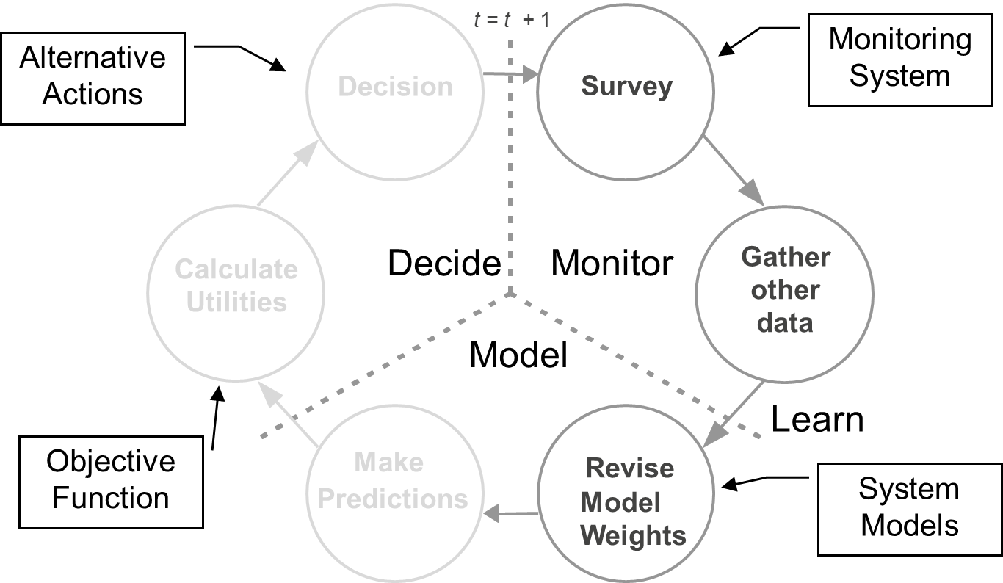

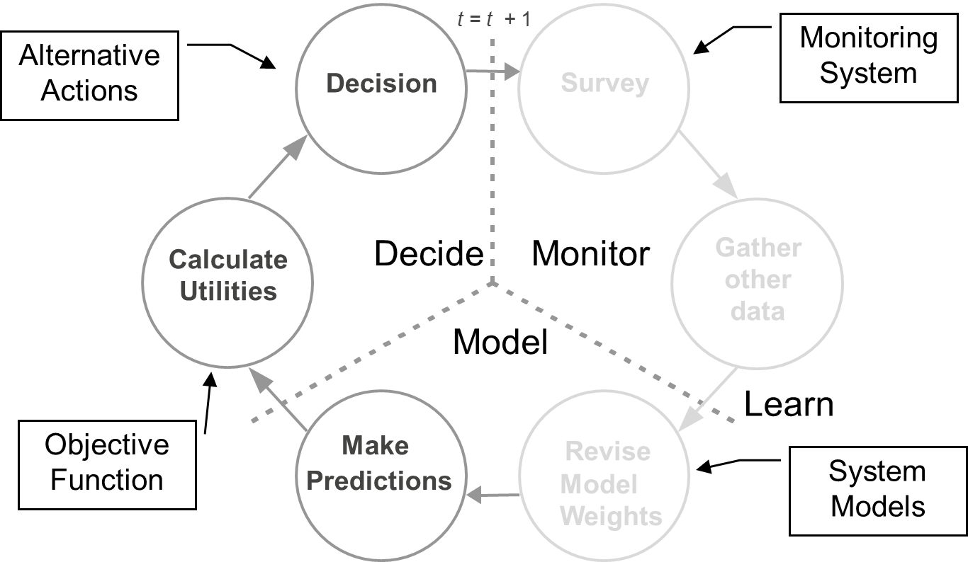

**THE ROLE OF MONITORING IN A DECISION CONTEXT**

Information means something different to a decision‐maker than it does to a scientist. In a decision context, there are specific roles for monitoring information (Lyons et al. 2008).

* Assess the state of the system, for state‐dependent decisions
* System state: attributes of the resource of interest that reflect management objectives and decision thresholds
* e.g., population size, occupancy, % coverage in invasives, % habitat
* Optimal management decision at present often depends on current system state
* Decision threshold: particular value of state variable may trigger a change indecision
* Example: annual waterfowl harvest regulations in the US are based on estimated population size and breeding pond numbers
* Evaluate management performance
* Monitoring should directly target the measurable attributes specified for objectives
* Focuses on how well the action implemented served to achieve management objective(s)
* Example: monitoring of changes in FL scrub‐jay occupancy probability following the implementation of prescribed burning
* Reduce uncertainty for improving future decisions
* Monitoring is used to compare model predictions to observed outcomes
* Discriminates among hypotheses regarding system dynamics (how the world works)
* focuses on key uncertainties represented by the model set
* Serves as a feedback loop for learning – reduction of uncertainty at each iteration for improving future decisions

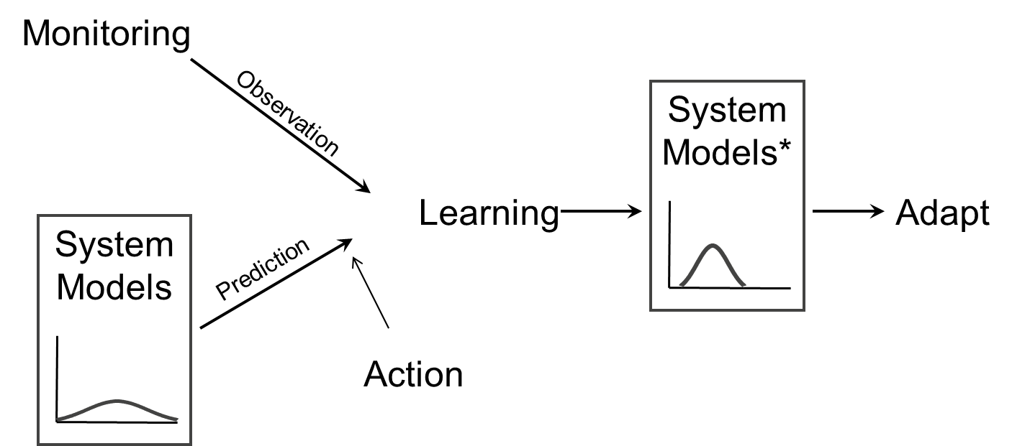

*Example: Evolution of model weights for 4 hypothesized dynamic responses of harvested mid‐continental mallard populations*

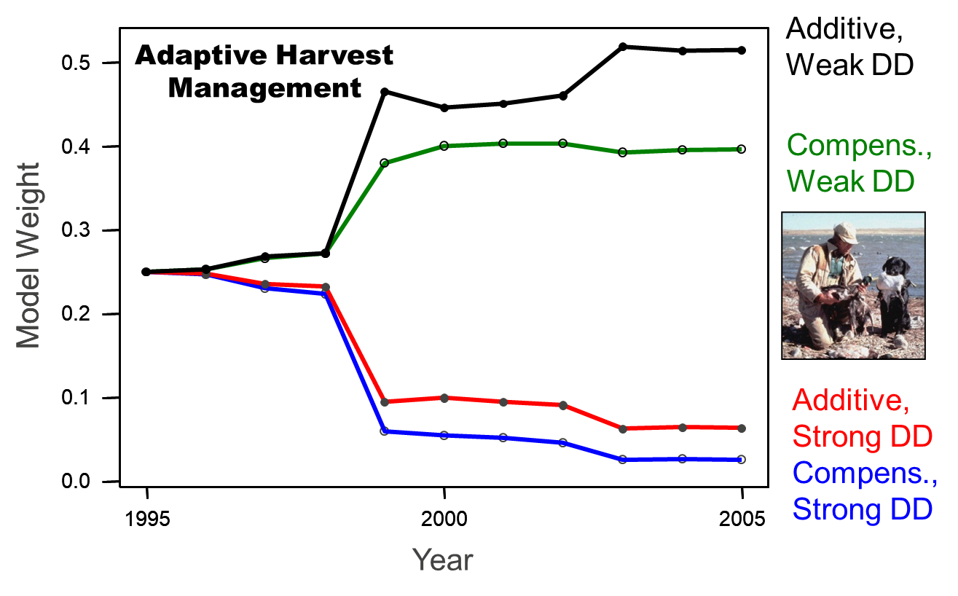

* Single‐, double‐, and triple‐loop learning
* Learning occurs at several levels
* Single‐loop: comparing the existing range of our understanding of the system. That is, it asks the question “are we doing things right?”
* Double‐loop: describes a re‐examination of the problem framing (values, objectives, alternatives, scale, etc.) following a period of single‐loop learning. That is, it asks the question “are we doing the right things?”
* Triple‐loop: examines the role of governance institutions, regulatory frameworks, etc., and questions their efficacy in managing resources. That is, it asks, “who has the right to do it?”

***Single‐, double‐ and triple‐loop learning (see Pahl‐Wostl 2009)***

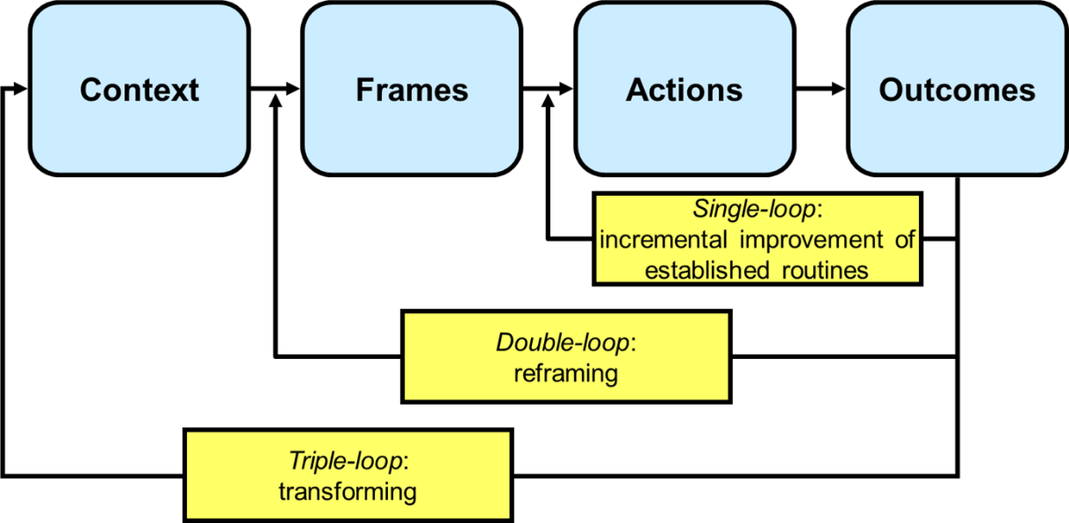

**REFERENCES**

Gunderson LH, Holling CS. 2002. Panarchy: understanding transformations in human and natural

systems. Island Press, Washington, D. C., USA.

Holling CS. 1973. Resilience and stability of ecological systems. Annual Review of Ecology and

Systematics 4:1– 23.

Johnson FA, Moore CT, Kendall WL, Dubovsky JA, Caithamer DF, Kelley JR, Jr., Williams BK. 1997.

Uncertainty and the management of mallard harvests. Journal of Wildlife Management 61:202‐216.

Johnson FA, Williams BK, Nichols JD. 2013. Resilience Thinking and a Decision‐Analytic Approach to

Conservation: Strange Bedfellows or Essential Partners? Ecology & Society 18:27.

Lyons JE, Runge MC, Laskowski HP, Kendall WL. 2008. Monitoring in the Context of Structured Decision‐

Making and Adaptive Management. Journal of Wildlife Management 72:1683–1692.

McFadden JE, Hiller TL, Tyre AJ. 2011. Evaluating the efficacy of adaptive management approaches: Is

there a formula for success? Journal of Environmental Management 92:1354‐1359.

Pahl‐Wostl C. 2009. A conceptual framework for analyzing adaptive capacity and multi‐level learning

processes in resource governance regimes. Global Environmental Change 19:354–365.

Olsson P, Folke C, Berkes F. 2004. Adaptive co‐management for building resilience in socio‐ecological

systems. Environmental Management. 34: 75‐90.

**MODULE DEVELOPED BY:**

Michael C. Runge, *USGS Patuxent Wildlife Research Center*

James D. Nichols, *USGS Patuxent Wildlife Research Center*

Fred A. Johnson, *USGS Wetland and Aquatic Research Center*

Mitchell J. Eaton, *DOI Southeast Climate Science Center*

Suggested Citation for this Module:

Runge MC, Nichols JD, Johnson FA, Eaton MJ. 2016. Dynamic decisions. Module 13 *in* Runge MC, Romito AM, Breese G, Cochrane JF, Converse SJ, Eaton MJ, Larson MA, Lyons JE, Smith DR, Isham AF, eds. Introduction to Structured Decision Making, 2016 edition. U.S. Fish and Wildlife Service, National

Conservation Training Center, Shepherdstown, West Virginia, USA.